

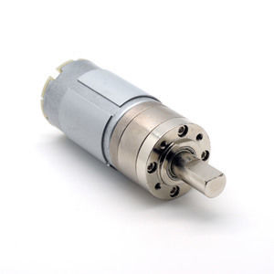

#### 36mm DC Planetary Gear Motor Series

**SPECIFICATIONS:**



**GEARBOX DATA:**

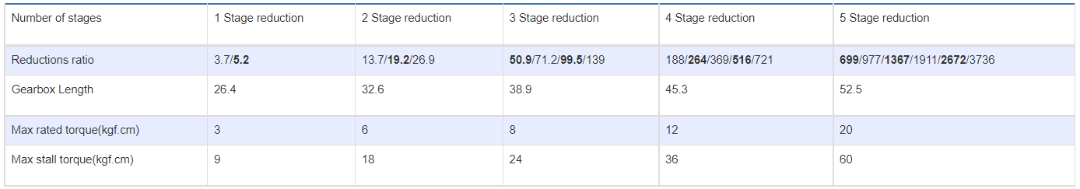

**GEARBOX OPTIONS:**

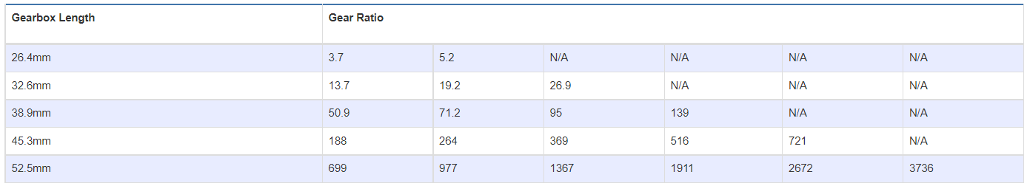

**SUBMODELS:**

*The following are common submodels for the LDO-36PGM555 series.*

